Home Page
From Idea to Business Growth — We're With You

Your Business Starts Here. We Help You Take the Right Step.
Starting a business can be confusing. What registration do you need? Which licence applies to your business? What should you do first?
Startbiz.in helps you find the right business solution — simply, clearly and professionally.
From GST, MSME, Shop Act and FSSAI to company registration, LLP, trademark, ISO, Import Export and GeM registration, we help businesses across Maharashtra take the right step.

Tell us what you want to do. We'll tell you what you need.
Whether you're starting a new business, formalising an existing business, or looking to grow, Startbiz.in is here to guide you.
[ Find My Business Solution ]
[ Talk to a Business Expert ]

Serving Businesses Across Maharashtra
Helping entrepreneurs and businesses navigate registrations, licences, certifications and business formalities.

INSTEAD OF THIS
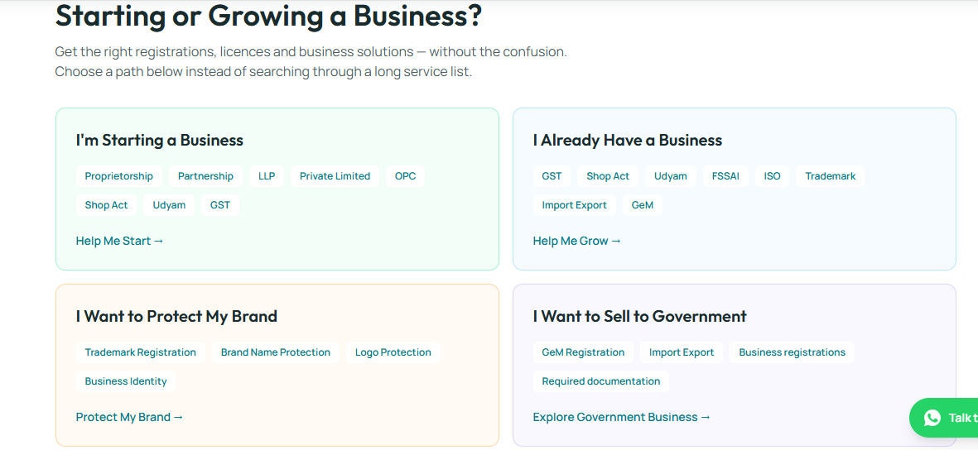

ADD THIS

What Are You Looking to Do?
Get the right registrations, licences and business solutions — without the confusion.
Choose what you want to achieve. We'll help you understand what you may need.

🚀 I'm Starting a Business
Choose the right business structure and take care of the essential registrations.
Popular solutions:
- Proprietorship
- Partnership
- LLP
- Private Limited
- Shop Act
- Udyam / MSME
[ Help Me Start → ]

📈 I Already Have a Business
Make your existing business more compliant, professional and ready for growth.
Popular solutions:
- GST
- Shop Act
- Udyam / MSME
- FSSAI
- ISO Certification
- Trademark
- Import Export
- GeM
[ Help Me Grow → ]

™️ I Want to Protect My Brand
Build and protect your business identity.
Solutions:
- Trademark Registration
- Brand Name Protection
- Logo Protection
- Intellectual Property Solutions
[ Protect My Brand → ]

🏛️ I Want to Do Business with Government
Explore registrations and solutions that can help your business participate in government procurement opportunities.
Solutions:
- GeM Registration
- Udyam / MSME
- Business Registrations
- Import Export
- Required Documentation
[ Explore Government Business → ]

Not Sure What You Need?
Don't worry. Tell us about your business and we'll help you identify the relevant registrations and business solutions.
[ Find My Business Solution → ]
Simple questions. Clear guidance. The right next step.

INSTEAD OF THIS
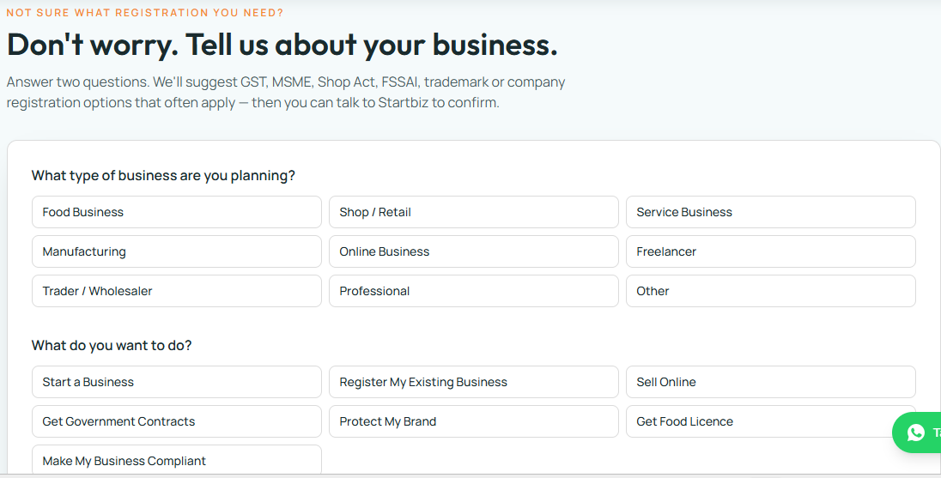

ADD THIS
Not Sure What Registration You Need?

Don't worry. Tell us about your business.
Answer 2 simple questions and we'll suggest business registrations, licences and solutions that may be relevant to you.
You'll get a starting point — not a complicated service list.

1. What type of business are you planning?
Food Business
Restaurant • Tiffin • Bakery • Food Manufacturing • Catering
Shop / Retail
Retail Store • Showroom • Grocery • General Store
Service Business
Consultancy • Agency • Repair • Salon • Professional Services
Manufacturing
Factory • Workshop • Product Manufacturing
Online Business
E-commerce • Online Seller • D2C • Marketplace Seller
Trader / Wholesaler
Distribution • Wholesale • Trading
Freelancer / Professional
Consultant • Designer • Developer • Freelancer
Other

2. What do you want to do?
🚀 Start a Business
📝 Register My Existing Business
🛒 Sell Online
🏛️ Sell to Government / Explore GeM
™️ Protect My Brand
🍴 Get a Food Licence
✅ Make My Business More Compliant

Find My Business Solutions →
We'll show you the registrations and business solutions that may be relevant based on your answers.
Need confirmation? Talk to a Startbiz Business Expert.

INSTEAD OF THIS
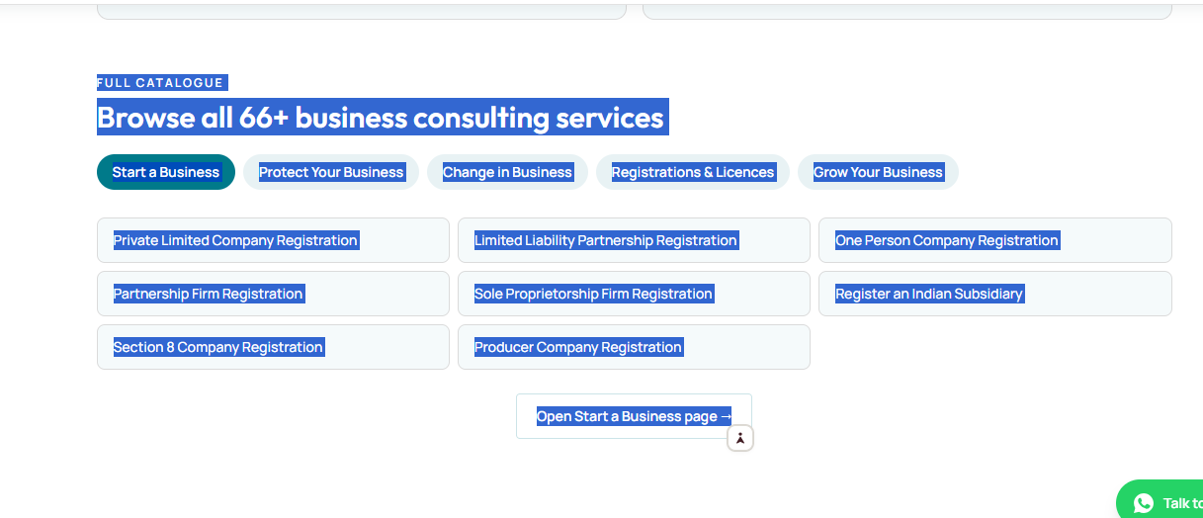

Yes. This is exactly the section we should change from a catalogue into a solution-oriented service discovery system.
Right now, the page is essentially:
66+ services → list of registration names → individual service pages
That is useful for someone who already knows what they need, but it does not solve the problem of a new or confused business owner.

Recommended replacement

Find the Right Business Solution
Not sure which registration, licence or business service you need?
Tell us a little about your business. We'll help you identify the relevant services and next steps.
[Find My Business Requirements →]
[I Already Know What I Need →]

What are you trying to do?
Instead of immediately showing 66+ services, show these five customer goals:

🚀 Start a Business
Choose the right business structure and complete the registrations needed to get started.
Explore →

🛡️ Protect Your Business
Protect your brand, maintain compliance and reduce business risks.
Explore →

🔄 Make a Change
Business name, constitution, ownership, address or other business changes.
Explore →

📋 Get Registrations & Licences
Find registrations, licences and certifications relevant to your business.
Explore →

📈 Grow Your Business
Prepare your business for expansion, online selling, government opportunities and new markets.
Explore →

Then keep the 66+ services
But move them below the solution finder.

Browse All Business Services
66+ services available
Search:
🔍 What are you looking for?
Filters:
Business Setup | Licences | Tax & Compliance | Brand Protection | Certifications | Government Business | Business Growth
Then show the services.
For example:

Company Registration
Private Limited Company
For businesses planning structured growth, multiple shareholders or investment.
LLP Registration
For businesses looking for a limited-liability structure with partnership flexibility.
OPC Registration
For an individual entrepreneur looking for a company structure.
Partnership Firm
For two or more people starting a business together.
Sole Proprietorship
For an individual running a business in their own name.
Indian Subsidiary
For eligible foreign businesses establishing an Indian entity.
Section 8 Company
For eligible non-profit/social-purpose organisations.
Producer Company
For eligible producer groups and organisations.

Most important change
I would not make this your homepage's primary message:
❌ Browse all 66+ business consulting services
Instead:

You Don't Need to Know the Registration.

Just Tell Us About Your Business.
Answer a few simple questions.
We'll help you identify what you may need.

[Start Business Checkup →]
Then below it:
Already know what you need?
Browse all 66+ services.

[View Full Catalogue →]

This creates two customer paths
STARTBIZ.IN
│
What do you need?
│
┌───────────┴───────────┐
↓ ↓
I DON'T KNOW I KNOW
│ │
Business Checkup Service Catalogue
│ │
Questions Search/Filter
│ │
↓ ↓
Requirements Service Page
│ │
└───────────┬───────────┘
↓
PERSONALIZED SOLUTION
↓
Documents Required
↓
Estimated Pricing
↓
Start Application
↓
WhatsApp / Expert
This is the direction I recommend for the Startbiz website.
And importantly, the 66+ services should remain—we are not removing them. We are putting a customer-problem-solving layer in front of them.
If you want, the next step should be to take your complete 66+ service list and I can restructure all 66 services into the 5 customer journeys + subcategories + recommendation logic, ready to give directly to your website developer.

Absolutely. I found our earlier Startbiz discussion and can now build the proper architecture instead of treating the 66+ services as a simple list.
One important point: I have the exact names of many services from our earlier work, but I do not have a verified complete 66-service master list in the conversation context. I won't invent the missing services. Below is the structure and recommendation engine we can use immediately, with the known services mapped into it. Once you give me the remaining catalogue, we can map every service exactly.

STARTBIZ.IN — NEW SERVICE ARCHITECTURE

1. The main customer question
The website should lead with:

What Do You Need Help With?
You don't need to know which registration you need.
Tell us about your business and we'll help you find the right solution.

[🔍 Find My Business Requirements]
OR

[📋 I Know What I Need — Browse Services]

2. Five main customer journeys
These should become the primary navigation, rather than making customers understand government terminology first.
Customer Goal | What Startbiz helps with
🚀 Start a Business | Choose business structure + initial registrations
🛡️ Protect Your Business | Brand, compliance, documentation
🔄 Change in Business | Amendments, changes, restructuring
📋 Registrations & Licences | Required registrations, licences & certifications
📈 Grow Your Business | Expansion, exports, government selling, scaling

3. JOURNEY 1 — START A BUSINESS

Customer says:
“I want to start my business.”
Don't immediately show 10 registration services.
Ask:

What type of business are you planning?
- 👤 Individual business
- 👥 Business with partners
- 🏢 Company
- 🌱 Startup
- 🌾 Producer/Farmer group
- ❤️ Non-profit organisation
- ❓ I'm not sure
Then Startbiz recommends the appropriate business-structure options.

Services mapped here
Business Structures
- Sole Proprietorship Firm Registration
- Partnership Firm Registration
- Limited Liability Partnership Registration
- One Person Company Registration
- Private Limited Company Registration
- Section 8 Company Registration
- Producer Company Registration
- Register an Indian Subsidiary

Next question:
What does your business do?
- Food
- Retail/Shop
- Manufacturing
- Service
- Trading/Wholesale
- Online business
- Professional/Freelancer
- Other
This answer then drives the second layer of recommendations.
For example:
START BUSINESS
↓
Business structure
↓
Business activity
↓
Location
↓
Products/services
↓
Expected turnover
↓
Selling method
↓
Required registrations
↓
Personalized Business Roadmap

4. JOURNEY 2 — PROTECT YOUR BUSINESS
Customer intent:
“I already have a business. I want to protect it.”
Show:

What do you want to protect or improve?
🏷️ My Brand
→ Trademark Registration
📜 My Business Compliance
→ Compliance-related services
🏅 My Business Credibility
→ ISO / applicable certifications
📄 My Business Documents
→ Business documentation support
⚖️ I Need Legal/Documentation Assistance
→ Legal documentation support

5. JOURNEY 3 — CHANGE IN BUSINESS
This is an important section because an existing business doesn't always need a new registration.
The customer should see:

Something Changed in Your Business?

What changed?
- Business address
- Business name
- Owner/partner details
- Business activity
- GST details
- Constitution/structure
- Licences
- Other
Then the system determines the appropriate service.
For example:
CUSTOMER
↓
"I need to change something"
↓
What changed?
↓
Which registration is affected?
↓
Required amendment/support
↓
Documents
↓
Apply
This is much more useful than simply displaying:
GST Amendment
GST Cancellation
etc.

6. JOURNEY 4 — REGISTRATIONS & LICENCES
This should be your service discovery engine.
Headline:

Find the Registrations Your Business May Need
Instead of asking:
“Which service do you want?”
ask:
“What does your business do?”
Then:

Example
Customer selects:
Food Business
The system can show relevant areas such as:
- FSSAI
- GST
- Udyam/MSME
- Shop & Establishment
- Other applicable licences
And explain:

Why this may apply to you
This is the key difference between Startbiz and an ordinary registration website.

7. JOURNEY 5 — GROW YOUR BUSINESS
Headline:

Ready to Grow Your Business?
Ask:

What are you trying to achieve?
🌍 Sell Outside India
→ Import Export / IEC-related assistance
🏛️ Sell to Government
→ GeM-related assistance
📈 Scale My Business
→ Growth Strategy / Scaling Consultation
🤝 Build a Franchise
→ Franchise Development Consulting
💡 Improve My Business Idea
→ Business Idea Evaluation
🚀 Start/Improve My Startup
→ Startup Consulting

8. CONSULTING SERVICES SHOULD NOT LOOK LIKE REGISTRATIONS
This is another important change.
Services such as:
- FREE Business Idea Evaluation
- Setup Consultation
- Startup Consulting
- Growth Strategy
- Scaling Consultation
- Franchise Development Consulting
- Process Guidance
should be presented as solutions, not buried in the service catalogue.
Create a section:

Not Sure What You Need? Talk to Startbiz

We can help you with:
💡 Business Idea
Is your business idea practical?
🚀 Business Setup
What structure and registrations should you consider?
📈 Business Growth
What should you do next to expand?
🤝 Franchise
Want to build a franchise model?

[Talk to a Startbiz Expert]

9. The Business Diagnostic
This should become the core technology/product of Startbiz.in.

Step 1

What are you trying to do?
○ Start a business
○ Already have a business
○ Change something in my business
○ Get a licence/registration
○ Protect my brand
○ Grow my business
○ Sell internationally
○ Sell to Government
○ I'm not sure

Step 2

What type of business do you have?
○ Shop/Retail
○ Food Business
○ Manufacturing
○ Service Business
○ Trading
○ Wholesale
○ Online Business
○ Freelancer/Professional
○ Other

Step 3

Where is your business?
○ Maharashtra
○ Other Indian state
○ Planning to start
○ Online/Pan India

Step 4

How do you operate?
○ Individual
○ Partners
○ Company
○ Not decided yet

Step 5

How do you sell?
☐ Physical shop
☐ Online
☐ B2B
☐ B2C
☐ Government
☐ Export
☐ Multiple channels

Step 6

What do you need help with?
☐ Registration
☐ Licence
☐ Tax/GST
☐ Brand protection
☐ Certification
☐ Documentation
☐ Government business
☐ Export
☐ Business growth
☐ Not sure

10. THE RESULT PAGE
This is where Startbiz becomes genuinely solution-oriented.
Instead of:
Here are 66 services
show:

Your Business Roadmap

Based on the information you provided:

🟢 BUSINESS SETUP
Sole Proprietorship / Partnership / LLP / Pvt Ltd / OPC
Why this is relevant:
Short explanation based on the customer's answers.
Priority: Recommended / Consider / Not applicable

[View Details]

🟢 REGISTRATIONS
Udyam/MSME
Why it may be relevant.

[Check Requirement]

🟢 TAX & COMPLIANCE
GST
Why it may apply based on the customer's business circumstances.

[Check GST Requirement]

🟢 LICENCES
FSSAI
Applicable if the business falls within the relevant food-business category.

[Check Requirement]

🟢 BRAND PROTECTION
Trademark
If the customer wants to build/protect a brand:

[Protect My Brand]

11. Don't say simply "YOU NEED"
This is important.
For regulatory services, the website should distinguish between:

Likely Applicable

May Apply

Optional / Business Advantage

Not Relevant Based on Your Answers
This prevents the website from making overconfident legal/regulatory claims.
For example:
GST — May Apply
Your answers indicate that GST registration may be relevant. Final applicability depends on your business activity, turnover, place of supply and applicable rules.
Then:

[Check With Startbiz Expert]

12. EVERY SERVICE PAGE SHOULD CHANGE
Your current service pages should not be just:
What is GST?
Documents required
Process
Price
Instead:

GST Registration

Is GST relevant to your business?
[Check in 60 Seconds →]
Then:

Who may need it?

Why it matters

What you need

Process

Estimated timeline

Startbiz assistance

FAQs

[Start My Application]

[Talk to an Expert]

13. Add a "Not Sure" button EVERYWHERE
This is one of the strongest conversion improvements.
If someone sees:
GST Registration
they should see:
Not sure if you need GST?

[Check My Requirement →]
Same for:
- FSSAI
- Trademark
- Shop Act
- Udyam
- ISO
- Import Export
- GeM
- Company Registration
This brings confused customers back into your diagnostic system.

14. Your 66+ catalogue should finally look like this
Instead of one huge list:

Business Solutions
Start a Business
- Business Structures
- Startup Consulting
- Setup Consultation
Protect Your Business
- Trademark
- ISO
- Compliance
- Documentation
Change in Business
- Amendments
- Changes
- Cancellation
- Restructuring
Registrations & Licences
- GST
- Udyam/MSME
- Shop & Establishment
- FSSAI
- IEC
- Other Licences
Grow Your Business
- GeM
- Import Export
- Growth Strategy
- Scaling
- Franchise
- Government Scheme Guidance

15. Search should be INTENT-based
Instead of only:
🔍 Search services...
Use:

What are you looking for?
Examples inside the search box:
“I want to start a food business”
“I want to register my company”
“Do I need GST?”
“I want to sell on GeM”
“I want to export”
“I want to protect my brand”
That is a much better experience.

16. The homepage should ultimately have this flow
STARTBIZ.IN
│
↓
BUSINESS BEGINS HERE
│
↓
"What do you want to achieve?"
│
┌───────────────┼───────────────┐
↓ ↓ ↓
START MANAGE GROW
│ │ │
↓ ↓ ↓
Business Compliance Expansion
Structure Changes Export
Registrations Licences GeM
│ │ │
└───────────────┼───────────────┘
↓
BUSINESS CHECKUP
↓
PERSONALIZED ROADMAP
↓
RECOMMENDED SERVICES
↓
PRICE + DOCUMENTS + PROCESS
↓
START APPLICATION
↓
WHATSAPP / EXPERT SUPPORT

The strategic change
Old Startbiz:
“We provide 66+ services.”
New Startbiz:
“Tell us what you're trying to do. We'll help you figure out what you need.”
The 66+ services become the engine behind the solution, not the product that the customer has to understand.

Next, I recommend we do the most important implementation step:
Send me the complete 66+ service list from your developer/current website. I will convert it into a master Startbiz Service Matrix with these columns:
Service → Customer Problem → Customer Journey → Business Type → Trigger Questions → Recommendation Logic → Priority → Documents → CTA → Cross-sell/Next Service

INSTEAD OF
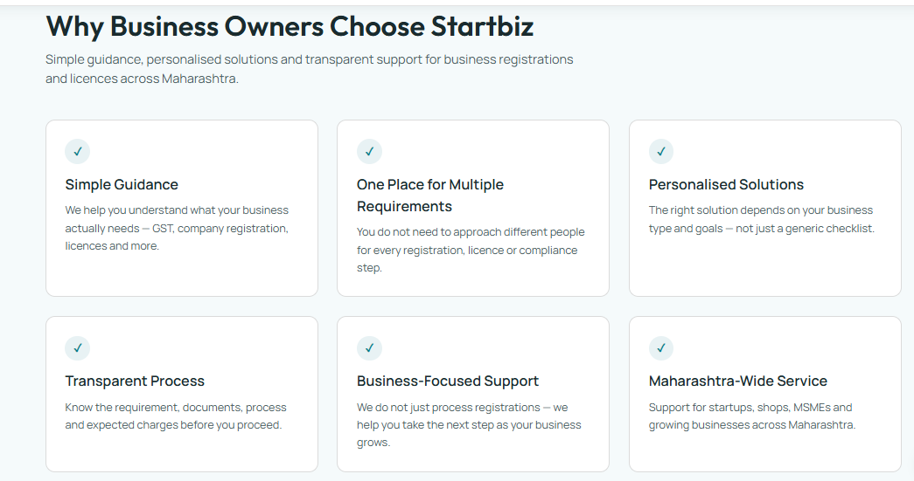

Yes. This “Why Startbiz?” section is directionally correct, but based on the solution-oriented website strategy we discussed, I would make it much stronger.
The current copy says what Startbiz does. The new version should communicate why a business owner should trust Startbiz to solve their problem.

Recommended replacement

Why Startbiz?

Your Business. Your Situation. Your Right Next Step.
Starting or running a business can involve registrations, licences, compliance, documentation and many decisions.
You don't have to figure everything out yourself.
Startbiz helps you understand your requirements, identify the relevant services and move forward with a clear business roadmap.

🔍 We Start With Your Business
We don't begin by asking:
“Which registration do you want?”
We first understand your business type, activity, goals and situation — then help identify the relevant requirements.

🧭 Get a Clear Business Roadmap
Instead of searching through dozens of services, get a structured view of:
What you may need → Why it matters → Documents → Process → Next Step

🏢 Multiple Business Requirements. One Place.
From business registration and licences to brand protection, certifications and business growth support, Startbiz brings multiple business requirements together in one place.

🎯 Solutions Based on Your Situation
Every business is different.
A shop, manufacturer, consultant, restaurant, trader and online seller may have different requirements.
We help you find the solution relevant to your business, rather than giving you a generic checklist.

💰 Transparent Before You Proceed
Understand the:
Requirement • Documents • Process • Service charges • Next steps
before you decide to proceed.

🤝 Support Beyond Registration
Your relationship with Startbiz shouldn't end when a registration is completed.
As your business changes or grows, you can return to Startbiz for your next business requirement.

📍 Maharashtra-Wide Support
Supporting entrepreneurs, startups, shops, MSMEs and growing businesses across Maharashtra.

But I would add one more section immediately below this
This is important for conversion.

Not Sure What You Need?

That's exactly what Startbiz is here for.
You don't need to know whether you need GST, Udyam, Shop Act, FSSAI, a company registration or another licence.
Tell us about your business. We'll help you identify the relevant next steps.

[Find My Business Requirements →]
Takes only a few minutes • Simple questions • Personalised roadmap

One major wording change I'd make
Your existing statement:
“We help you understand what your business actually needs — GST, company registration, licences and more.”
is good, but it can accidentally suggest that Startbiz itself determines legal applicability.
I'd use:
“We help you understand which registrations, licences and business services may be relevant to your business and what to do next.”
That is more accurate and fits the diagnostic model better.

The overall message should now be:
66+ Services
↓
You don't need to know which one you need
↓
Tell us about your business
↓
Startbiz understands your situation
↓
Personalised Business Roadmap
↓
Relevant services + documents + process + next step
↓
Start Application / Talk to Expert
That is the core product experience I would build the entire Startbiz.in website around—not just a prettier version of the existing information website.

WEBSITE BLUEPRINT
Absolutely. Let's turn the entire Startbiz.in website into a customer-solution platform.
Below is the developer-ready website structure I recommend.

STARTBIZ.IN — CUSTOMER-SOLUTION WEBSITE BLUEPRINT

1. HEADER / NAVIGATION

Logo
Startbiz.in

Main Navigation
Find My Requirements ⭐
Start a Business
Protect My Business
Change in Business
Registrations & Licences
Grow My Business

Header CTA
[Talk to an Expert]
On mobile, keep:
☰ Menu | Find My Requirements | WhatsApp

2. HOMEPAGE HERO

Business Begins Here

Don't Know What Your Business Needs?

Start With Your Business. Not With a Registration.
Tell us about your business, goals and current situation.
We'll help you identify the registrations, licences, certifications and business services that may be relevant to you.

[🔍 Find My Business Requirements]
Simple questions • Personalised roadmap • Clear next steps
Secondary CTA:
[Browse 66+ Services]

3. "HOW CAN WE HELP?" SECTION

What Are You Trying to Do?
Don't know which service to choose?
Start with your goal.

🚀 Start a Business
Choose a suitable business structure and understand your initial requirements.
[Start My Business →]

🛡️ Protect My Business
Protect your brand, strengthen your business and stay organised.
[Protect My Business →]

🔄 Change My Business
Need to update, modify or restructure something?
[Make a Business Change →]

📋 Get Registrations & Licences
Find registrations, licences and certifications relevant to your business.
[Find Requirements →]

📈 Grow My Business
Explore opportunities to expand, export, sell to Government and scale.
[Explore Growth →]

4. THE HERO FEATURE
This should become the signature Startbiz feature.

Not Sure What You Need?

Let Startbiz Help You Find Out.
Answer a few simple questions about:
Your business → Your activity → Your location → Your goals
We'll create a:

Personalised Business Roadmap

[Start Business Checkup →]

5. BUSINESS CHECKUP

Step 1 — What are you trying to do?
- Start a new business
- Already running a business
- Change something in my business
- Get a registration/licence
- Protect my brand
- Grow my business
- Export
- Sell to Government
- Not sure

Step 2 — What type of business?
- Retail
- Food
- Manufacturing
- Trading
- Wholesale
- Service
- Professional
- Online
- Freelancer
- Other

Step 3 — How is your business structured?
- Individual
- Partners
- Company
- Not decided

Step 4 — How do you sell?
- Physical store
- Online
- B2B
- B2C
- Government
- Export
- Multiple

Step 5 — What do you want to achieve?
Multiple selections:
- Start legally
- Get licences
- Get GST
- Get MSME/Udyam
- Protect brand
- Get certification
- Export
- Government selling
- Expand
- Franchise
- Other

6. RESULT PAGE

Your Business Roadmap

Based on the information you provided

🟢 BUSINESS STRUCTURE
Recommended options
Short explanation.
[View Options]

🟢 REGISTRATIONS
Udyam / MSME
Why it may be relevant:
Explanation based on the customer's answers.
[Check Details]

🟡 TAX / COMPLIANCE
GST
Why it may apply:
Explanation.
[Check Requirement]

🟢 LICENCES
FSSAI
Applicable where relevant to the customer's business activity.
[Check Details]

🔵 BRAND
Trademark Registration
For businesses planning to build and protect a brand.
[Protect My Brand]

⭐ YOUR NEXT STEP

Start with these requirements

[Get My Complete Roadmap]

[Talk to a Startbiz Expert]

7. IMPORTANT: USE "MAY APPLY"
For regulatory recommendations, don't have the system blindly say:
❌ You MUST get GST
Instead:
GST — May Apply
And explain:
Based on the information you provided, GST registration may be relevant. Final applicability can depend on factors such as business activity, turnover, place of supply and applicable rules.
This makes the system more responsible and professional.

8. WHY STARTBIZ
Use the revised version we created:

Why Startbiz?

Your Business. Your Situation. Your Right Next Step.
Starting or running a business can involve registrations, licences, compliance, documentation and many decisions.
You don't have to figure everything out yourself.

🔍 We Start With Your Business
We understand your business situation before suggesting relevant services.

🧭 Get a Clear Business Roadmap
What you may need → Why → Documents → Process → Next Step

🏢 Multiple Requirements. One Place.
Business registrations, licences, certifications, brand protection and growth support.

🎯 Solutions Based on Your Situation
Different businesses have different requirements. We help you identify what may be relevant to yours.

💰 Transparent Before You Proceed
Understand requirements, documents, process and expected charges before proceeding.

🤝 Support Beyond Registration
Return to Startbiz as your business changes and grows.

📍 Maharashtra-Wide Support
Support for entrepreneurs and businesses across Maharashtra.

9. SERVICE CATALOGUE
Don't put this near the top of the homepage.
Place it after the solution sections.

Browse 66+ Business Services

Search
🔍 What are you looking for?
Example:
“I want to register my company”
“Do I need GST?”
“I want to start a food business”
“I want to export”

Filter by Goal
All
Start a Business
Protect Your Business
Change in Business
Registrations & Licences
Grow Your Business

10. SERVICE CARD DESIGN
Instead of:
Private Limited Company Registration
Use:

Private Limited Company Registration
For: Entrepreneurs planning to operate through a private limited company structure.
Good for:
Startups • Growing businesses • Multiple shareholders
You'll learn:
✓ Eligibility
✓ Documents
✓ Process
✓ Expected charges
✓ Next steps

[View Solution →]

11. EVERY SERVICE PAGE
Every service page should follow this structure:

Service Name

Is this the right solution for your business?
[Check My Requirement →]

What is it?
Simple explanation.

Who may need it?
Relevant business types.

Why consider it?
Benefits / purpose.

What you'll need
Documents/information.

Process
1 → 2 → 3 → 4

Expected charges
Clearly separate:
Government/statutory fees
Startbiz service charges
where applicable.

Timeline
Use appropriate qualified wording rather than guaranteed timelines.

FAQs
5–8 questions.

Need help deciding?
[Talk to an Expert]

Ready?
[Start Application →]

12. "I DON'T KNOW" SHOULD BE EVERYWHERE
This is a powerful conversion mechanism.
For example:

GST Registration
Not sure whether GST applies to your business?
[Check My Requirement →]

Private Limited Company
Not sure which business structure is right for you?
[Compare My Options →]

FSSAI
Not sure which food licence applies to you?
[Find My Requirement →]

Trademark
Not sure whether you should register your brand?
[Talk to an Expert →]

13. TRUST SECTION
Add:

Trusted by Businesses Across Maharashtra
Use your genuine numbers here.
For example, if currently verified:
500+ Businesses Served
50+ Franchise Partners
Maharashtra-Wide Support
Do not mix different historical numbers such as 500+ and 1,000+ unless you have a clear definition and current evidence for each.

14. CUSTOMER STORIES
Instead of generic testimonials:

Real Business Problems. Practical Solutions.
Example format:

Food Business
Problem:
Customer wanted to start a food business but didn't know which registrations were relevant.
Startbiz helped with:
Business setup + applicable registration/licence guidance.
Outcome:
Customer had a clear roadmap to proceed.

15. FINAL CTA
At the bottom of every important page:

Not Sure Where to Start?

Start With Your Business. We'll Help You Find the Next Step.
[🔍 Find My Business Requirements]
[💬 Talk to a Startbiz Expert]

16. WHATSAPP LEAD FLOW
Don't simply put:
WhatsApp Us
Instead use contextual messages.
If customer is on GST page:
Hi Startbiz, I want to check whether GST registration may be applicable to my business.
If customer is on company registration:
Hi Startbiz, I'm planning to start a business and need help choosing the right business structure.
If customer completes the diagnostic:
Hi Startbiz, I completed the Business Checkup and would like help with my Business Roadmap.
This gives your team context before the conversation even starts.

17. LEAD CAPTURE
Don't force a long registration form at the beginning.
First:
Business Checkup
Then at the result:

Want your personalised roadmap?
Name
Mobile
Email
City
Preferred contact method

[Get My Roadmap]
This should dramatically reduce friction compared with asking for 10–15 details before providing any value.

18. DEVELOPER ARCHITECTURE
Tell your developer that Startbiz should have three layers:

LAYER 1 — CUSTOMER INTENT
What does the customer want?
↓

LAYER 2 — BUSINESS DIAGNOSIS
Business type
Activity
Structure
Location
Sales channel
Goals
↓

LAYER 3 — SERVICE ENGINE
Relevant services
↓
Reason
↓
Priority
↓
Documents
↓
Price
↓
CTA
This means your website can eventually support 100+ services without becoming confusing.

19. THE BIGGEST CHANGE
Your current website thinks like this:
CUSTOMER
↓
SERVICE CATALOGUE
↓
SERVICE PAGE
↓
CONTACT
I want Startbiz to work like this:
CUSTOMER
↓
"WHAT ARE YOU TRYING TO DO?"
↓
BUSINESS CHECKUP
↓
UNDERSTAND BUSINESS
↓
PERSONALISED ROADMAP
↓
RELEVANT SERVICES
↓
DOCUMENTS + PROCESS + PRICE
↓
START APPLICATION
↓
WHATSAPP / EXPERT
↓
FOLLOW-UP

That is the real transformation of Startbiz.in.
You are no longer presenting yourself as:
“A company that provides registrations.”
You are positioning Startbiz as:

“A business solution platform that helps entrepreneurs understand what they need and what to do next.”
That should become the central product philosophy behind your website, not just a marketing slogan.

I recommend improving the FAQ, About, Portfolio, Contact and Footer sections as follows.

1. FAQ: Turn questions into business solutions
Recommended website copy

Your Business Questions, Answered
Starting a business raises many questions. Find straightforward answers about registrations, licences, business structures and compliance.
Here are the eight questions you already have, with answers that help customers decide what to do next.
How do I know which registration my business needs?
Your requirements depend on your business activity, location, structure, turnover and how you sell. Start with our Business Solution Finder to identify potentially relevant registrations and licences.
Find My Business Requirements
Is GST mandatory for every business?
Is Udyam the same as GST?
What is the difference between a company name and a trademark?
Proprietorship, LLP or Private Limited—which should I pick?
Do you only sell registrations?
What fees should I expect?
Does Startbiz decide legally what I must take?
Each FAQ should also have its own relevant link. A visitor reading about GST should go directly to the GST eligibility check, not to a generic contact page.
Important correction for your developer
Udyam registration is free on the official government portal. Do not describe a Startbiz assistance charge as a government registration fee or imply that Startbiz is an authorised government registration portal. Include a link to the
official free Udyam portal
.
Udyam Registration
+1
GST guidance should likewise distinguish preliminary screening from a final applicability assessment.
CBIC Tax Information
+1

2. About Startbiz: Focus on the customer's journey
Replace the existing long introductory paragraph with shorter, more purposeful copy.
Suggested About section

From Business Idea to Business Growth

Your business journey deserves clear guidance at every step.
Startbiz helps new entrepreneurs and existing business owners across Maharashtra understand their business requirements, explore relevant registrations and licences, and access support as their businesses grow.
Whether you're starting your first shop, registering a company, launching a food business or preparing to sell to government buyers, begin by telling us what you want to achieve.

500+
Satisfied customers*

Maharashtra
Statewide service
*Publish the customer count only after confirming it against your business records.Find My Business Solution

3. Replace Portfolio with Business Solutions
Your existing Portfolio section displays GST, LLP, Shop Act and other registration pages. Those are services, not examples of completed work.
Rename the section Explore Solutions for Your Business and organise it by the problems customers want to solve.

What Can We Help You With?
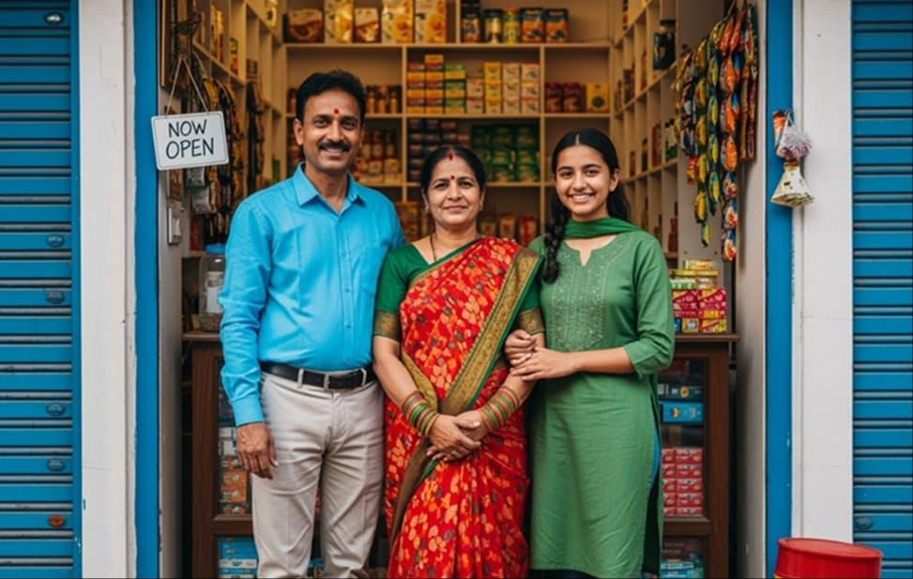
Starting a new business?
Understand your structure and initial registrations.
Explore options

Starting a food business?
Explore FSSAI and other potentially relevant requirements.
Explore options

Selling products online?
Check GST and other requirements for your sales model.
Explore options

Planning to grow?
Explore MSME, certification and business expansion support.
Explore options
Keep actual client case studies in a separate section called Customer Success Stories, once you have verified client examples and permission to publish them.

4. Contact: Make it a business requirement form
Your current Contact section asks visitors to call, email or WhatsApp you. Give customers a way to describe their problem before they contact you.
Proposed contact form

Tell Us About Your Business
Answer a few questions so the Startbiz team can understand your requirement before contacting you.
What do you need help with?
Start a new business
GST, MSME or other registration
Business licence
Change existing business details
Trademark or brand protection
Business expansion
Not sure — need guidance
What type of business?
Retail or shop
Food business
Manufacturing
Trading or wholesale
Services or consultancy
Online business
Other or not decided
Your name
City
Tell us more (optional)
Continue to WhatsApp This example opens WhatsApp with the information entered. Your developer can also connect the form to your lead-management system with the customer's consent.
The website should also give customers the option to request a callback instead of using WhatsApp. In your internal dashboard, save the enquiry category, business type, city, date, source page and follow-up status.

5. Correct the contact details before launch
Confirmation needed
Your current website displays 75192 21199 and starbiz.in@gmail.com. Earlier Startbiz materials used a different mobile number, and some materials used startbiz.in@gmail.com.
1. Which is your official Startbiz contact number?
+91 75192 21199
+91 94035 99797
Another number
2. Which email should appear on the website?
startbiz.in@gmail.com
starbiz.in@gmail.com
Another email
3. Confirm your business hours
Monday–Saturday, 9 AM–6 PM
Monday–Friday, 9 AM–6 PM
Different hours
Confirm contact details
Once confirmed, use the same contact information in the header, footer, contact page, WhatsApp links, QR code and structured business information. The WhatsApp example above currently uses the number on your existing website; your developer should update it if you confirm a different number.

6. Simplify the footer
The current footer repeats several links, including Start a Business. Keep it organised into four groups.
Business Solutions | Resources | Startbiz | Contact
Start a Business | Solution Finder | About Us | Call
Registrations & Licences | Compare Structures | Why Startbiz | WhatsApp
Protect Your Business | Knowledge Centre | Customer Stories | Email
Change in Business | Industry Solutions | FAQs | Business Hours
Grow Your Business | All Services | Contact
Add a clear statement that Startbiz is an independent business facilitation service, not a government department. Include Privacy Policy, Terms of Service, Refund Policy and appropriate professional-service disclosures.

7. Development priorities

Recommended implementation order
A practical sequence for your website developer.
Implementation checklist
0 of 6 completed
Connect the Solution Finder
Make the finder recommend relevant services and send visitors to the appropriate pages.
Create the personalised roadmap
Show why a service may apply, required documents and the next action.
Improve lead capture
Connect contextual forms, WhatsApp and your internal enquiry records.
Replace the Portfolio
Use problem-based business solution cards instead of repeating the service catalogue.
Improve FAQ and About
Publish clear answers, accurate claims and direct links to relevant actions.
Clean up contact and footer
Confirm contact information, remove duplicate links and add essential policies.
Copy developer checklist
The most important deliverable is the Business Solution Finder. Your revised FAQ, service pages, About section and contact forms should all lead visitors toward it. That way, the website helps customers understand their requirements before asking them to purchase a service.

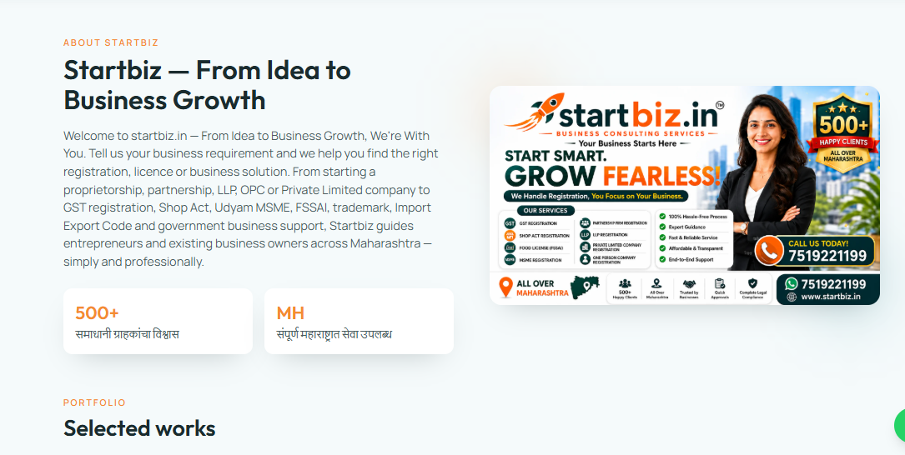

Yes. This About Startbiz section should be improved to match the new solution-oriented positioning we are building.
The current version is good as an introduction, but it still sounds like a registration-service company. We want visitors to understand that Startbiz helps them figure out what they need and what to do next.

Recommended final version for the website

About Startbiz

From Idea to Business Growth — We're With You
Starting or running a business can involve registrations, licences, compliance, documentation and many decisions.
Startbiz helps you understand your business requirements and find the right next step.
Whether you're starting a new business, running an existing business or planning to grow, you can tell us about your business and explore the registrations, licences, certifications and business solutions that may be relevant to your situation.
From proprietorship, partnership, LLP, OPC and Private Limited company registration to GST, Shop & Establishment, Udyam/MSME, FSSAI, Trademark, Import Export and Government business support, Startbiz brings multiple business requirements together in one place.

Our approach is simple:
Understand your business → Identify your requirements → Explain your options → Help you take the next step
We aim to make business registration and compliance simpler, clearer and more accessible for entrepreneurs and existing businesses across Maharashtra.

[Find My Business Solution →]

Your trust indicators
I would keep these, but make the wording more professional:

500+
Businesses Served

MH
Maharashtra-Wide Support
If 500+ is your verified current figure, keep it. If the actual current number is different, update it rather than using an older marketing figure.

I would also add this immediately below the About section

What Makes Startbiz Different?

🔍 Start With Your Requirement
You don't have to know the name of the registration or licence you need. Tell us what you're trying to achieve.

🧭 Get a Clear Direction
We help you understand relevant requirements, documents, processes and possible next steps.

🏢 Multiple Business Solutions
Access support across business setup, registrations, licences, brand protection, certifications and growth-related requirements.

🤝 Support as Your Business Grows
Your requirements can change as your business changes. Startbiz is designed to support you beyond the first registration.

One important change to the tagline
Your current:
“From Idea to Business Growth, We're With You.”
is strong and I would keep it.
But pair it with this supporting line:
“Tell us what you want to achieve. We'll help you understand what you need and what to do next.”
That combination clearly communicates the new Startbiz concept:

From Idea to Business Growth — We're With You.

Tell us what you want to achieve. We'll help you understand what you need and what to do next.
This should become one of the core messages throughout the website.

INSTEAD OF THIS


Yes. This section should become the final CTA of the website, but I would make it more action-oriented and consistent with the Business Solution Finder we designed.

Recommended final version

Startbiz — From Idea to Business Growth

We're With You.
Whether you're starting a new business, running an existing business or planning your next stage of growth, Startbiz helps you understand your requirements and find the right next step.
You don't need to know which registration or licence you need.
Tell us about your business and we'll help you explore the relevant registrations, licences and business solutions for your situation.

[🔍 Find My Business Solution →]
Answer a few simple questions and get a personalised business roadmap.

[💬 Talk to a Business Expert →]
Have a specific question? Talk to the Startbiz team.

Small but important UX change
I recommend changing:
Find My Business Solution
to:
Find My Business Requirements
on the diagnostic/finder itself, because the visitor is actually discovering their requirements.
Then use:
Get My Business Solution
as the CTA after the results.
So the customer journey becomes:
Find My Requirements → Business Checkup → Your Business Roadmap → Get My Business Solution
That is clearer than sending every visitor directly to a generic service catalogue.

